EXPERIMENT 15 PPS
15.1.1//Car dealership sales system
Ans: ALGORITHM:
Step 1: Start
Step 2: Define a base class Car
- Declare attributes: brand, price, model, color
Step 3: Define constructor __init__()
- Initialize all attributes using input values
Step 4: Define method display_details()
- Print brand, price, model, and color (each on separate line)
Step 5: Define derived class Car1
- Inherit from class Car
- Override method display_details() to print details
Step 6: Define derived class Car2
- Inherit from class Car
- Override method display_details() to print details
Step 7: Read input for first car
- Store values: brand1, price1, model1, color1
Step 8: Read input for second car
- Store values: brand2, price2, model2, color2
Step 9: Create object car1 of class Car1
- Pass first car details
Step 10: Create object car2 of class Car2
- Pass second car details
Step 11: Call display_details() for car1
- Print first car details
Step 12: Call display_details() for car2
- Print second car details
Step 13: Stop

FLOWCHART: 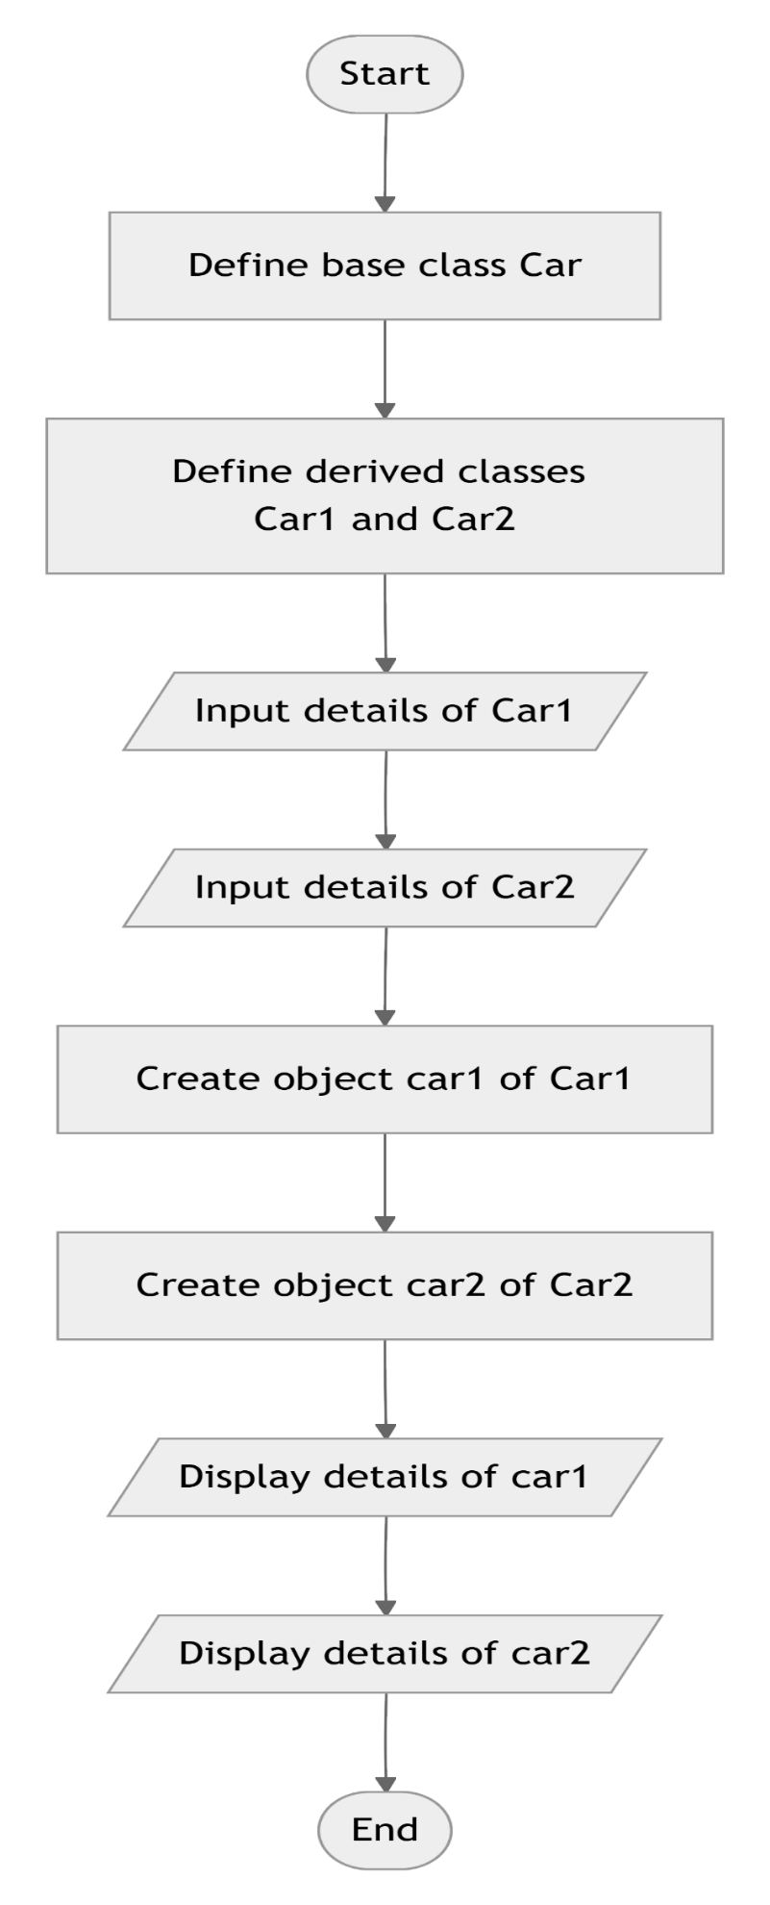

CODETANTRA:
